# **PROJECT: CART VALUE AND BUSINESS DEVELOPMENT ANALYSIS**

By Phu Vinh Nguyen

## **I - Project Overview:**

A food company wants to produce the highest profit for the next marketing campaign, scheduled for the next month. A pilot campaign involving 2205 customers was carried out, customers who bought the offer were properly labeled

### I.I - Goals of the project 🎯

**Business Goal:**

* Increase the business profits by targeting features that help increase shopping cart value of an individual.

**Questions to answer:**

* Which model is the best to explain the whole picture of the business?
* Determine which elements contribute to a customer’s cart value significantly?
* How important are those features? Statistical evidence?
* Which insights and solutions can be drawn from the analysis?

### I.II - Data sources 🗂️

Name: **Marketing Analytics**

Link: <https://www.kaggle.com/datasets/jackdaoud/marketing-data/data>

The data set ifood_df.csv consists of 2205 customers of XYZ company with data on:

* Customer profiles
* Product preferences
* Campaign successes/failures
* Channel performance

### I.III - Data overview 🔍

* The datasets has 2205 rows and 39 columns with usability score of 9.41

*The only partial dictionary of each variable found in ifood_df.csv

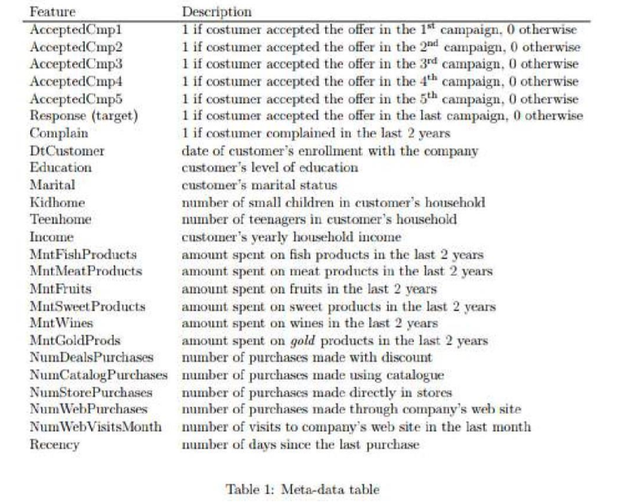

## **II - Overall Plan:**

### II.I - Data Cleaning 🛠️

* Clean all the missing values, duplicates
* Convert the data types
* Handle outliers
* Rename the columns

*Analytical Tools: Python

### II.III - Exploratory Data Analysis (EDA) 👨‍💻

* Overview columns and summarize statistics for all variables
* See which categories contribute to the cart value the most
* Unveil visualizations to uncover patterns and relationships

*Analytical Tools: Python

### II.II - Analysis 🧮

* Testing Regression Model
* Build hypotheses to see which traits influence customer spending behaviors

*Analytical Tools: Python

### II.IV - Visualization 📊

* Build charts, dashboards on Power BI
* Python visualization libraries

### II.V - Data Storytelling 💬

* Structure the script (Headlines, ideas) on PowerPoint/ Canva
* Make sense of all the numbers by facts and insights for better decision-making in the business.

### II.VI - Insights and Recommendations 💡

* Presenting findings and initiatives on PowerPoint/ Canva
* Build up strategies for business based on concrete evidence found during analysis.

## **III - Deliverables:**

- Slides presentation: storytelling + visual + insight

- Code and Documentation: Github: [README.md](http://readme.md), All code files

- Final Report: project’s purpose, methodologies, findings, and recommendations.